Note: Mainstream astronomers now are openly suggesting that our Sun does indeed have a dual and is part of a binary system - just as Sri Yukteswar said in 1894. See Part 2.
Segment 2d Part 1 – The Yugas of Sri Yukteswar and Kriya Yoga – additional text that is relevant to the yugas video is below. This information is presented to support the understanding that the quality of human consciousness declined for thousands of years unto around 540 A.D., then began improving after that date.
By Larry Dominus Reavis, Ph.D.
Please feel free to share this file with others; but if you modify it, please identify the modifications as your own so that they won't be confused with the author's text.

Here is the video of the yugas (or download it and play it on your hard disk; or watch on Youtube - P1, P2, P3); if you wish to download it so that you can burn it to a BD or DVD, click hi-bit version:
According to NASA, "Our Sun is unusual in that it is alone - most stars occur in multiple or binary systems." But according to Sri Yukteswar, our Sun is not unusual - it, too, is part of a binary star system. And the consequences?
Among other topics, the above video describes the Flynn effect - the worldwide increase in IQ scores during the 20th century; and other evidence that IQ has been increasing for at least a couple of centuries. It also describes the terrible decline in abstract reasoning ability that was evident during the dark ages - with consequent barbaric behavior. You can download it here.
The following graphic shows the Greek concept of the Great Year (the inner circle), plus the yugas (the outer circle) - as described by Sri Yukteswar.
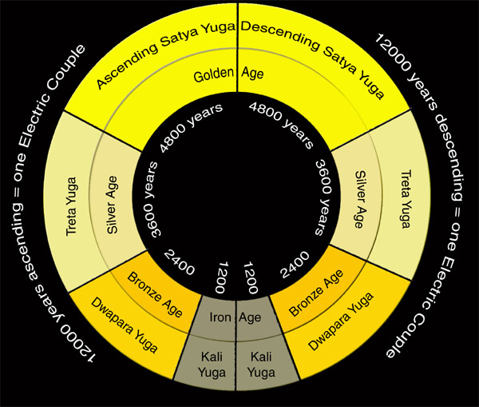
Introduction - modern knowledge compared to ancient knowledge
Presuming that there is no wind and that gravity is constant, the amount of time that a pendulum takes for each swing is not affected only by the length of the pendulum. Knowing this, in 1668 the English philosopher John Wilkins proposed a universal system of measurement, based on a unit that he called the meter, to replace the great variety of measuring systems that were in use during his time (see Wikipedia). He defined his meter as the length of a pendulum that would take one second to swing from left to right (known as a "seconds pendulum").
However, the French knew that subtle variations in gravity at different locations on Earth would affect the period of a pendulum. Therefore there would be errors in the definition of the meter if based on pendulums.
For that reason, in the 18th century the French chose to define the length of a meter as a precise fraction of the Earth's polar circumference. After precisely measuring the distance from the equator to the North Pole, the French chose to define the length of one meter as one ten-millionth of that distance - which results in a polar circumference of 40 million meters.
Even though this modern definition of a meter was based on the polar circumference of the Earth, the length of a seconds pendulum is almost exactly one meter (in Paris, the length of the seconds pendulum is now known to be precisely .99385 meters). In other words, each swing of a pendulum that is almost exactly one meter long requires one second. Thus the meter and the second are corresponding units of length and time.
"Coincidences"
Because the meter was defined as a certain fraction of the Earth's polar circumference only recently, whereas humans have divided the day into 86,400 seconds for ages, the fact that there is an intimate connection between the meter and the second of time has to be a coincidence - for the ancients could not have know of that relationship. Right?
The speed of light in empty space is 300,000,000 meters per second. The measured speed currently is 299,792,458 meter per second. Just a coincidence that it's such a nice, round number, right? Since 1983, the length of a meter has been based on this number rather than the circumference of the Earth. Why? The circumference of the Earth varies from place to place because of mountains and other anomalies, whereas the speed of light is the same no matter where on Earth the measurement takes place. This constancy reduces the ambiguity of the meter's definition while maintaining almost exactly its original length - about 39.37 inches..
(Note: Back when I was designing transmitting antennas, I had to include a "velocity factor," because electromagnetic propagation along a wire is slower than the speed of light in free space. Similarly, the speed of light passing through our atmosphere is slower than light that is propagating through spaces that are far from the Earth; and light travels even more slowly through water. My guess: If "empty" space were swept clean of all solar wind particles, intergalactic dust, and other matter, probably the speed of light would be exactly 300,000,000 meters per second instead of a tiny fraction of one percent slower.)
Another "Coincidence": The velocity of the Earth as it travels around the Sun is about 30,000 meters per second; 29,770, to be exact). Just a coincidence of course that it comes so close to being a nice, round number and almost exactly one 10,000th the speed of light.
But enough about the French meter (there are too many other "coincidences" to list all of them here).
The French then constructed a cube with each edge having a length of a 10th of a meter and filled it with distilled water. At standard temperature, they defined the volume of the water to be 1 liter and the weight to be 1 kilogram. Thus was born the modern metric system.
Thomas Jefferson submitted a similar metric system to Congress before the French had completed theirs. Unlike the French who adopted the metric system, the U.S. Congress rejected Jefferson's. Thus the French get credit for crafting the modern metric system rather than the U.S.
Financially, adoption of the metric system by the French was a boon for them, for all scientific work and almost all manufacturing and all financial systems worldwide now are based on the metric system (except the U.S. - the only industrialized country that has not adopted it). In contrast, the awkward system used in the U.S. - 12 inches to the foot, 3 feet to the yard, 5280 feet to the mile, 32 degrees for freezing, 212 for boiling, ounces, pints, quarts, etc. - has increasingly hampered the U.S. in its attempts to compete effectively with other nations.
However, Jefferson was both shocked and puzzled to discover that the old British system had its own interesting coincidences. For example, 1000 ounces avoirdupois of water occupies exactly 1 cubic foot! Many other such coincidences were discovered by Jefferson. After long study, he concluded that the British - and now the U.S. - system had its roots in"very high antiquity," according to his July 4, 1890 report to Congress (see p33 of Civilization One).
"Modern" metric system?
The French scientists had their own comeuppance for their "modern" metric system. Even though they did know that the second of time was used in ancient Mesopotamia thousands of years ago (those ancients, living in the area of modern-day Iraq also divided the day into 86,400 seconds, just like we do, with the same 24 hours per day), guess what?
After the French created the modern metric system, excavations in Mesopotamia discovered an even older civilization in that area, the Sumerian. Modern French scientists soon were embarrassed to discover that the ancient Sumerians also had created this "modern" metric system of which the French were so proud. The ancient Sumerians - or some even older civilization - no doubt did this by going through the same thinking processes that the 18th-century French used. Not bad, for the 5000-year-old Sumerian civilization.
Moreover, it is thought that the second of time already was ancient even when the Sumerians were known to be using it many thousands of years ago. Well, at least our modern scientific measuring system has caught up with that which was created thousands of years ago; aren't we smart?
Another remarkable measurement system devised by the ancients
In the early 20th century, Alexander Thom - a professor of engineering at Oxford - was studying the engineering aspects of British megalithic structures. These date from almost 6000 years ago until about 3000 years ago. Over a period of 50 years Professor Thom reached the conclusion that their basic unit of measure for length was what he called the "megalithic yard." One megalithic yard (MY) = 2.722 feet.
It has long been believed that Stonehenge and the other megalithic structures studied by Professor Thom were connected with astronomical phenomena. This becomes obvious when one knows that the "sidereal year" (the number of rotations of the Earth relative to the stars) consists of 366 days (our 365 solar days, plus Earth's one yearly rotation around the sun - rounded off to the nearest whole day.
Therefore, thousands of years ago the sidereal year in which the circle that the Earth makes as it travels around the Sun naturally was divided by the ancients into 366 units - each resulting from one rotation of the Earth - and siderial year of 366-per-year rotations became the basis for dividing any circle into 366 units. The ancients modified the 366 degrees of arc for a circle slightly so that a circle was defined to have 360 degrees - which we, too, now use. They probably did that in order to make calculations easier: 360 can be divided by 10 and many other numbers with whole-number results. In contrast, 366 does not divide into many whole-number units and thus was abandoned for most practical purposes.
Little did Thom know that his Megalithic Yard (MY), together with the sidereal system of 366 degrees in a circle, would produce their own coincidences. In the following, note the central role played by 366 - the number of degrees (as used by megalithic civilizations) in a circle - when each "degree" is defined by the actual number of Earth rotations in a sidereal year (this information is mostly taken from Before the Pyramids; incidentally, the authors of that book submitted the following "coincidences" to a society of British statisticians who concluded that these "coincidences" could not be attributable to chance alone):
1. 100 of the professor's Megalithic Yards (MYs) times the number of days in one sidereal year (that is, 100 x 2.722 feet x 366) = the number of feet for the moon's polar circumference.
2. The sun's circumference is 40,000 MYs times 366. (Remember that the Earth's polar circumference in 40,000,000 meters; just a coincidence, of course.)
3. The Earth's polar circumference in MYs is 366 squared.
4. If temperature is defined as zero degrees at water's freezing point and the boiling point is defined as 366 degrees, absolute zero then equals a very convenient minus 1000 degrees. Note that our modern metric (centigrade) system still takes the freezing point of water as the zero point on its scale.
5. Continuing: If the circle is divided into 366 degrees (each such degree henceforth referred to as a "megalithic degree"), then 366 MY equals one second of arc of the Earth's circumference if a second is defined as 1/6th of a minute of arc, and the minute is defined as 1/60th of a megalithic degree. In other words, we're defining a system of measuring arcs that is identical to ours except that their minute of arc has 6 seconds instead of our 60 seconds per minute of arc, and the total circle is divided into 366 degrees instead of our 360.
Incidentally, the second of arc of the Earth's circumference that we currently use, in contrast to the highly meaningful MY second, is a meaningless 30.87 meters long. This length is neither convenient nor related to any systematic set of relationships.
6. 366 MY = 1000 Minoan feet. Minoan culture flourished about 4000 years ago. Their unit of measurement of one foot of length was a bit shorter than our foot. In other words, one megalithic second of arc of the Earth's circumference = a very convenient 1000 Minoan feet.
Again, there are too many more such "coincidences" to include here.
But now it gets seriously weird (see Before the Pyramids):
6. Observatory Circle was built in Washington, D.C. by the Navy in 1893. Its purpose, according to the act of Congress that mandated its construction, was to "observe the Sun, Moon, planets . . ." etc. (search the web for references - the government seems to change its web pages often). Its diameter is two megalithic degrees of arc of the Earth's circumference.
7. The Washington Ellipse shows a similar pattern of megalithic measurements.
8. The rest of Washington, D.C., and even the Pentagon, incorporates megalithic units of measure, according to Before the Pyramids (look at their color-plate drawings #11, 12, and 13 with their corresponding text reporting the MY measurements of Washington, D.C). You can verify their claims by using the measuring tool in Google Earth.
According to historical documents, Washington, D.C. was laid out by George Washington and other high-ranking members of the Freemasons. Probably Benjamin Franklin's success in getting Europeans to fund the American Revolution can be attributed in large part to his connections with fellow Freemasons in Europe:
"While in Paris Franklin used his Masonic contacts to raise funds to buy arms for the American rebels."
It is probable that our country could not have gained freedom from British rule had it not been for the Masons; and - had it come into existence by other means - almost certainly would have reflected predominant sentiment at the time that would have made life difficult for Jews and others who did not comply with dominant religious sentiment. Of course, fundamentalists are disturbed by our freedom of religion and presumed Judaic influence (see the website link above).
"As mankind become more liberal, they will be more apt to allow, that all those, who conduct themselves as worthy members of the community are equally entitled to the protection of civil government. I ever hope to see America among the foremost nations in examples of justice and liberality." – President Washington to a committee of Roman Catholics (March 1790) "
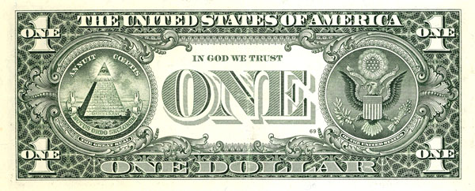
The dollar bill shows the Great Seal of the U.S. It is replete with Masonic symbols, including the pyramid, the spiritual eye, the 6-pointed star of Judaism (just above the head of the eagle), and more.
Be that as it may, the Freemasons claim possession of ancient knowledge. It does indeed appear that ancient Masonic knowledge was used to plan Washington, D.C. As supporting evidence, George Washington presented himself in full Masonic regalia when the cornerstones of some of the District's main buildings were laid (see photo).
Similarly, another high Mason - President Franklin D. Roosevelt - overruled the military plans for a huge, rectangular central command building and instead ordered a pentagon of certain dimensions (specified by a person appointed by himself). Moreover, he did not place this pentagon-shaped building where the military brass had proposed, but instead where it now is located. When asked why, Roosevelt reportedly gave no reason, but replied, "I believe I'm still the commander in chief of the military." So why did Roosevelt place the Pentagon where we now find it? In order to extend the Masonic pattern of the city.
The above is presented as evidence that a very high understanding of astronomy and mathematic measurement existed thousands of years ago. As suggested above, some of it was, in certain practical ways, superior to our own modern systems of measurements.
As implied above, some of that ancient knowledge has survived to the present day. That survival sometimes resulted from preserved knowledge - as in the case of the Freemasons. Other ancient knowledge was rediscovered - as in the case of the French metric system.
How did the ancients know so much? And why did that knowledge get lost?
Sri Yukteswar, the guru of Paramahansa Yogananda, says that the Earth goes though yugas.The dark-age yugas are known as the kali yugas. The nadir of the last kali yuga occurred around 540 A.D.
Fortunately, each kali yuga eventually gives way to the second yuga, known in Sanskrit as the dwapara yuga. A couple of centuries ago we entered the dawning of the dwapara yuga. The third yuga, in Sanskrit, is the treta yuga. If you speak most any Indo-European language other than English, you'll recognize a number progression here, from dwapara to treta (2 to 3).
The name of the highest yuga is not based on this number progression, but is based on the sat, which is the Sanskrit equivalent for God the Father. Hence, the highest yuga is known as the satwa yuga - and can be thought of as God the Father's yuga. You can see the lengths of each yuga by studying the outer circle shown in the above drawing.
Greek ages
All of this is much like the Greek "ages of man." The ancient Greek defined an iron age - the lowest "dark" age, followed by a second "bronze" age. After the bronze age came the silver age, at last giving way to a golden age. These are seen in the inner circle of the drawing above. Many ancient cultures had similar concepts of cyclical ages, including native American cultures, according to Villasenor.
Even the Bible has a description of the ages that is almost identical to that of the Greeks - as shown about 3.5 minutes into this summary video.
According to Sri Yukteswar, these cycles, or yugas, are related to what astronomers call "precession of the equinox." (See the first video on this page.) However, Sri Yukteswar differs from most modern astronomers regarding the cause of precession. Because he includes the motion of the sun as it moves around its ellipse in addition to the wobble of the Earth, Sri Yukteswar says one complete cycle of an ascending yuga sequence, followed by a descending yuga sequence, requires about 24,000 years (of course, it's a coincidence that the number of millennia in one of Sri Yukteswar's ascending or descending yuga sequences equals the number of months in a year). If you would like to read the details, see Lost Star, by Walter Cruttenden. David Frawley also has written or coauthored several books that discuss Sri Yukteswar's yugas. Or - if brave (or grew up in a culture where these ideas are not so foreign) - you could attempt to read Sri Yuktesware's own book, The Holy Science. In that book, he also explains why the energy of consciousness - labeled "chi" or "qi" by the people of the Far East; prana by the people of India; or simply "life energy" by Yoganandaji - waxes and wanes over the 24,000-year cycle (his explanation will be detailed in Part 2 of this treatise).
Sri Yukteswar argued that during the higher ages only a thin veil of maya separated humans from God the Father. If so, then one can understand why the ancient Indians named the highest yuga the satwa yuga - God the Father's yuga. The result was that many people achieved full realization easily, and many more came close. Because of their union or near union with God, they shared the attributes of all fully-realized saints, including omniscience. By means of their omniscient intuition, they knew much that was lost during the later decline into the dark age.
If one accepts this view, it is easy to understand how the ancients in many cultures achieved profound understanding of our universe, and then created the necessary mathematics to express that understanding of space and time - resulting in their basic unit of time (the second), their time-related metric system, etc.
Interesting side note
But even if - some 14,000 years ago (approximately the high point of the last high age) - they possessed the knowledge that many modern authors attribute to them, why should inheritors of that knowledge, millennia later, use that knowledge to go to all the effort to build the 100+ henges of the British Isles and the other monumental construction projects found all around the world?
Because, claim many authors, including those who wrote Civilization One and Before the Pyramids, the ancients wanted to have an early warning system for incoming asteroids that might again splash down in the ocean and create another catastrophic flood. (Caution: Even if this explanation is true, it might not be the sole purpose for those huge undertakings.)
Geological evidence for the Great Flood now is being reported by archaeologists such as Bruce Masse. Moreover, stories of a huge flood are found in ancient cultures all over the world, even in the Americas. They probably have a basis in some pre-historic disaster, and the henges and other astronomical observatories - like Observatory Circle in Washington D.C. - would have been able to detect a light in the sky that didn't seem to be moving like the stars. Instead, it would seem to be standing still - if it were coming straight at us. Given the fact that the Earth is rotating, only such observatories could have allowed humans to spot a motionless "star" that was moving toward us. The huge henges would have provided sufficient accuracy to provide many months or even years in which to prepare for the crash (the larger the henge, the greater the accuracy).
Our universe created by chance?
The gurus of SRF - Jesus Christ, Bhagavad Krishna, Mahavatar Babaji, Lahiri Mahasaya, Sri Yukteswar, and Paramahansa Yogananda - also accept the belief that our universe did not evolve totally by chance. Yes, evolution of the universe and species happens according to natural laws, and such evolution takes a very long time indeed (eons, says Yoganandaji). But natural evolution is not the only truth: God guides the process, say these great ones.
For just one more "coincidence" example, why should apparent diameter of the moon perfectly match the perceived diameter of the sun as seen from Earth? (It is this "coincidence" that allows astronomers to study the corona of the sun during a full eclipse.) Noting many more astonishing astronomical "coincidences," the authors of Civilization One remark that their work has shaken their agnosticism. Countless physicists also have commented on the amazing coincidences in our "Goldilocks" universe (or read The God Theory or other similar books that also have been written by Ph.D. physicists).
The point? This universe is not chaotic. Rather, it enables "the unreasonable effectiveness of mathematics," to quote Eugene Wigner (Nobel Laureate in physics). As physicist Paul Davies has noted, it didn't have to be that way. Without a guiding intelligence, there is no reason to believe that our universe would have been other than unremitting chaos. After all, where do the laws of physics come from? Why should math formulas result in predictions that later - sometimes many decades later - physicists were able to confirm? Could such an intricate set of orderly relationships emerge just by chance? Not a chance - say a growing number of scientists.
And the superior connection to this all-pervasive, law-making intelligence that was enjoyed by those who lived during the higher ages enabled them to intuitively know this mathematics. It was this knowledge that they handed down to the Hindus, the Sumerians, Egyptians, and other ancient cultures that came long after the golden satya yuga ended.
In addition to the mathematics of physical laws, knowledge of spiritual laws also was prevalent during the higher ages. Even more important, people lived those spiritual laws during the higher ages. That's why the barbaric behavior noted in the Flynn-effect video prevailed everywhere during the dark ages - but not to the same extent in our slightly advanced age, nor (with many exceptions) in the highly advanced ages of thousands of years ago.
Consider the remarkable decline in violence
Example: Many people today seem to believe that more people have died during modern times by violence than during the dark ages. Not so. Even during the bloody 20th century, only 5% to 7% of the population died violently. The rest died by natural causes. If you wish to see the evidence that documents the remarkable decrease in violence recently, see A History of Force: Exploring the Worldwide Movement against Habits of Coercion, Bloodshed, and Mayhem, by James. L. Payne (2004). Now we also have Winning the War on War, Twilight of the Nation State, and The Better Angels of our Nature: Why Violence has Declined.
The decline in violence is dramatic. Here are some examples, according to Michael Shermer (in his Oct., 2011 Scientific American p90 article, which draws heavily on Stephen Pinker's book, The Better Angels of our Nature; Shermer is publisher of the Skeptic magazine):
1. In 14th-century Oxford, the homocide rate was about 110 per 100,000. In London today, the rate is less than one per 100,000. That is better than a 100-to-1 improvement. Similar trend have been documented in other nations.
2. Violent deaths of all kinds have declined from about 500 per 100,000 in pre-state societies (prior to William the Conqueror, who - according to some historians - established the first nation state in the 11th century) to around 50 during the Middle Ages to fewer than one per 100,000 in most of Europe. Homicide rates in the U.S. are of course higher; but even here the rate is only about five per 100,000.
3. Even during the violent 20th century with its terrible world wars, only about 3% of the world's population died in violence or the famines and other problems attributable to violence - according to Shermer. In contrast, prestate scocieties lost about 15% of their population to war - according to the author of Our Better Angels.
When the Earth sank into the dark ages (its nadir was around 540 AD), humans lost much of their understanding (in addition to reverting to animal-like behavior). For example, the ancient Indians knew that the Earth was a globe and was rotating on its axis. So did the ancient Sumerians mentioned above.
European decline
Unfortunately, that knowledge was lost: Europeans during the dark ages believed that the Earth was flat (the last remnant of the Flat-Earth Society died out in my lifetime). Perhaps even worse, the official dogma of European churches, both Protestant and Catholic, held that the Earth was motionless. Because of this belief, declared to be "infallible" by the Pope Alexander VII (see 2c-physics), Bruno was excommunicated by the Lutherans because of his Copernican heresy, and the Catholic church had him burned alive, partly because of his insistence that the Earth was not the stationary center of the universe. The Indian Hindus showed a similar decline in knowledge, and lost their understanding of, for example, the length of the yugas, according to Sri Yukteswar. (Many modern Indians continue the error, erroneously believing that each yuga lasts many 10s of thousands of years.)
The Jews - the most literate?
There was a time when Jews ceased writing? Say it ain't true! But that's the claim of Israel Shahak in Jewish History, Jewish Religion., who says on p49 "But from 800 AD on, when more detailed historical information is again available . . ." Here he is referring to his claim that almost all Jewish writing stopped between 500 AD and 800 AD, and then resumed after that date. This period of life in Palestine and Mesopotamia - the locale of Shahak's investigation - corresponds nicely to the darkest of the "dark ages," as defined by historians as that period when almost all scholarly activity, such as writing, seemed to stop almost all over the world. That period also corresponds nicely with Sri Yukteswar's claim that the nadir of the last dark age (Kali yuga) occurred round 540 A.D.)
Jewish spiritual decline during the dark ages
Early Judaism has so many examples of advanced spiritual knowledge that one hardly knows where to start the list. We've already mentioned the Jewish understanding of the yugas.
A more important example: The central story of Judaism is the story of the exodus from bondage to Pharaoh. Please note that comments published with the recent translation of the Old Testament by Conservative Judaism, the Etz Hayim, states that probably the exodus never happened - at least not as described in the Bible; and that some details, such as the fall of the walls of Jericho, are historically false (as stated also by Wikipedia).
Be that as it may, the spiritual truth of this story is confirmed by Yoganandaji. According to him, the enslavement to Pharaoh represents our enslavement to our ego and its craving for the comforts of sense gratification. As you may recall from that Biblical story, many of those who escaped with Moses soon wanted to return to the comforts of Egypt - just as many ambitious spiritual seekers soon want to abandon their new disciple and return to their old ways in order to "sow their wild oats." Accordingly, the great battle for freedom from Pharaoh represents our battle to replace the illegitimate ego dictator with the rule of soul - the rightful ruler of ourselves. It's the same battle story as that told in the Bhagavad Gita.
And Jericho? The sound of the horns that destroyed the protective wall of Jericho represents the sound of Aum that is heard by one and all during deep meditation. The fall of Jericho was the first victory by the followers of Moses, just as for many meditators, the hearing of Aum is the first victory on the march toward self-realization.
Jesus the Jew
Jesus always saw himself as a Jew, and all of his disciples were Jews. Jesus came to the Jews because they were more spiritual than others of their generation. But the limited ability to think abstractly during the dark ages resulted in a materialistic interpretation of his words by the Jews of his day. When Jesus said, "the kingdom of God is within," they grappled with the non-materiality of that "kingdom." Unfortunately, most didn't get it and instead expected a material kingdom in which the Roman rulers would be replaced by Jewish rulers. During the dark ages, most people are only capable of materialistic understanding such as this.
Even the close disciples of Jesus could not grasp a non-material, spiritual kingdom. Evidence of their failure to understand can be found in Acts: 1:6 “When they therefore were come together, they asked of him, saying, Lord, wilt thou at this time restore again the kingdom to Israel”? Clearly, they were expecting a material, Earthly kingdom, a political freedom of Israel from the Roman Empire, not the kingdom within spoken of by the Gospel of Luke and other Biblical passages, as well as the Gospel of Thomas. Such was the spiritual decline during the dark ages that even the disciples of Jesus didn't get it. And that passage from Acts took place after the resurrection, and after the entire ministry of Jesus on earth. Even after all the teaching of the entire ministry of Jesus, his disciples still could not get beyond their limited materialistic understanding.
Even today, some people whom psychologists describe as "concrete thinkers" are still expecting Jesus to come again and establish a material kingdom. They expect this material kingdom despite the fact that Jesus said of the second coming: "Verily I say unto you, There be some standing here, which shall not taste of death, till they see the Son of man coming in his Kingdom." - Matthew 16:28
So where are those to whom Jesus promised that they would see the Son of Man come in his Kingdom before they tasted of death? All gone, long ago. So was Jesus wrong? Not a chance. They did indeed see the Son of Man in his Kingdom when they achieved self-realization before dying. Materialists who insist that a material kingdom is coming with Jesus as its Earthly ruler really must engage in twisted logic to square their belief with this verse. But as we enter the dwapara yuga, those who expect a material kingdom become fewer with each passing decade.
Buddhist decline
Even the ascetic Buddhism, which teaches how to achieve freedom from desire, sometimes degenerated into debauchery during the Dark Ages. According the Dalai Lama, "They were pleasure seekers" - The Story of Tibet, p74.
Hindu spiritual decline
The caste system once placed 12-year-old children into their proper caste after observing their character during their childhood. Those who were very spiritual were placed in the Brahma caste. Those who were loyal and vigorous in their protection of others were placed in the warrior kshatriya caste; and so on. But with the arrival of the dark ages, the caste system degenerated into a rigid system that was designed to perpetuate the privileges of the few who were powerful.
And - like Buddhist decline - Hinduism totally failed to understand the spiritual teaching of kundalini power. Where the ancient scriptures recommended the raising of the sexual energy up the spine so that it could be sublimated into spiritual energy, those living in the dark ages began to believe that sexual arousal was necessary in order to accomplish this feat. Thus the temples that were built about 1800 years ago sometimes were covered in pornography that is not fit to be viewed by those who are trying to conquer their enslavement to sex.
Sanitation decline
"The people of the Harappan civilization in Pakistan and north-western India had water-flushing toilets in each house that were linked with drains covered with burnt clay bricks." - Wikipedia. This civilization which flourished almost 5000 years ago between the Indus river and the Ganges (the home of the even more ancient Hinduism) was not the only one that enjoyed advanced plumbing: "According to Teresi et al. (2002):^{[19]} The third millennium B.C. was the 'Age of Cleanliness.' " (Quote from Wikipedia, referenced above, ca. 2009.) The ancient inhabitants of other parts of India, in addition to the ancient inhabitants of modern-day Scotland, also had toilets and running water. But these were only for the rich, whereas the people of Harappa provided sanitation for every family.
Not even the U.S. of my childhood provided such luxury (my own paternal grandparents did not have running water or modern toilets; plumbing didn't get installed in that Independence, Missouri house until about 1950). But sanitation 100 years earlier was much worse. Even in advanced London, poop was piled as high as a two-story house as recently as the 1840s (see The Ghost Map).
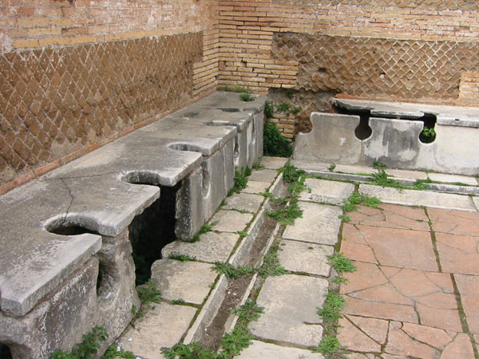
Public toilets persisted until the end of the Roman empire, some 1700 years ago, as shown above. Public domain photo.
Graphic evidence of decline and rise of human artistic faculties
Human artifacts older than 4000 or 5000 years are scarce, but they do exist. Among the most fascinating are the paintings found in hundreds of caves in Europe, especially the nearly 2000 cave paintings near Lascaux, France. Radioactive carbon dating show these to be 15,000 years old or older. I found it especially fascinating that their Wikipedia page (ca. 2009) noted that the “crossed-bison” painting (and I quote):
. . . is often held as an example of the skill of the Paleolithic cave painters. The crossed hind legs show the ability to use perspective in a manner that wasn't seen again until the 15th century.
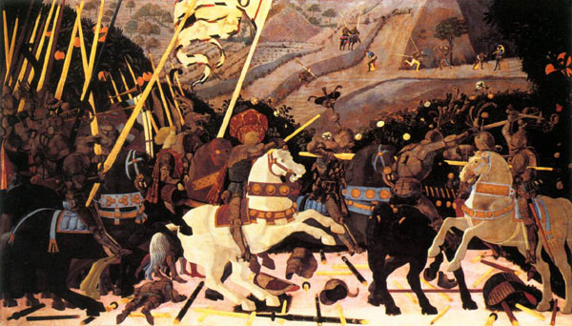
According to Gregory Curtis, an art journalist, this ability to use perspective was not reborn until the arrival of Paolo Uccello in the 15th century. (The professor who taught my art appreciation class at the University of Missouri also gave an animated class on the disappearance of perspective during the dark ages, followed by its re-appearance in recent centuries.) Notice that the figures in the background of this Uccello painting (above) clearly are smaller than figures in the foreground, giving the drawing an admirable sense of depth.
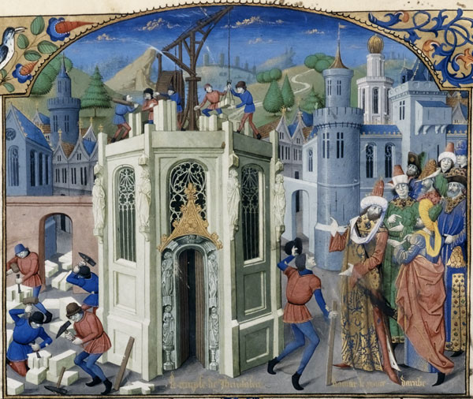
Even when perspective was starting to be used again just before the renaissance, it was confused, as shown in this picture which was painted about 1250 AD. Notice that the lines of the Jewish temple in Jerusalem – and yes, that tollbooth-like structure is supposed to be the great temple – those temple lines, when extended, don't even come close to meeting at a vanishing point.
Moreover, the figure in the right foreground is too small compared to the crowd behind him, and those in the rear of the crowd appear as large as those in front. On the left we have figures that appear to be in front of the temple, closer to the viewer than the crowd on the right; but, nevertheless, they are much smaller than the figures in the crowd – making them look like midgets. And – no offense to people of small stature – who would want to hire such tiny people as those shown on the roof to be stone masons? Clearly, the painter does a credible job of dealing with concrete objects. The physical bodies of the people are realistic; but his limited ability to think abstractly is inadequate to the task of ordering the objects in a way that conveys perspective. My art appreciation professor made much of the errors shown in that painting.
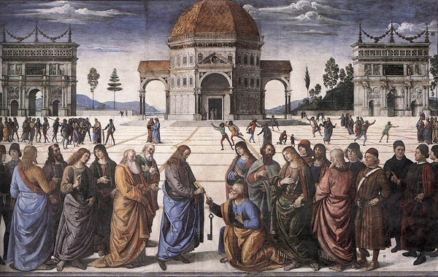
Notice the improved perspective of the picture from more than two centuries later. Clearly, all the lines converge at a single vanishing point. Indeed, this painter seems to be shouting to us, “I get the point” - vanishing point, that is.
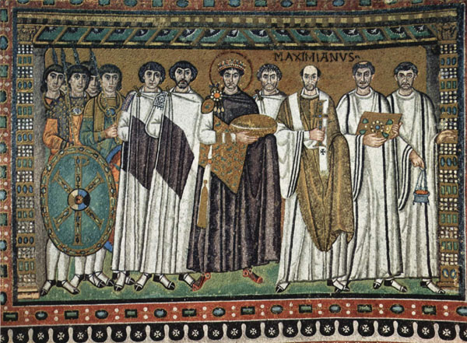
In contrast, earlier European art always looked flat, like the above painting.
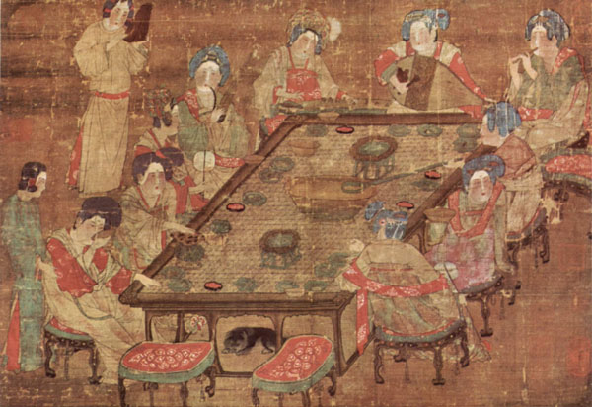
People from the Far East usually score higher on IQ tests than others. So did Asian artists do better during the dark ages? Well what do you think – does the table look right to you in the above 10th century painting? Me neither. The problem is, the front lines and the rear lines of the table are exactly the same length. Obviously (to us), the lines in front should be longer than the lines at the rear of the table, and the left and right lines of the table should NOT be parallel (but they are). The result is a sort of optical illusion that makes the table look too wide at the far end.
But by the 18th century, this Japanese painter got it right. Notice how the lines at the edges of the white paper on the desk, if extended, would cross at about the same vanishing point as the lines at the left edge and right edge of the table. And, of course, the horizontal line of the paper that is farthest from us (nearest to the scribe) is shorter than the line that is nearest to us (farther from the scribe).
Not only could 18th century artists get it right, they also could get it wrong – intentionally:
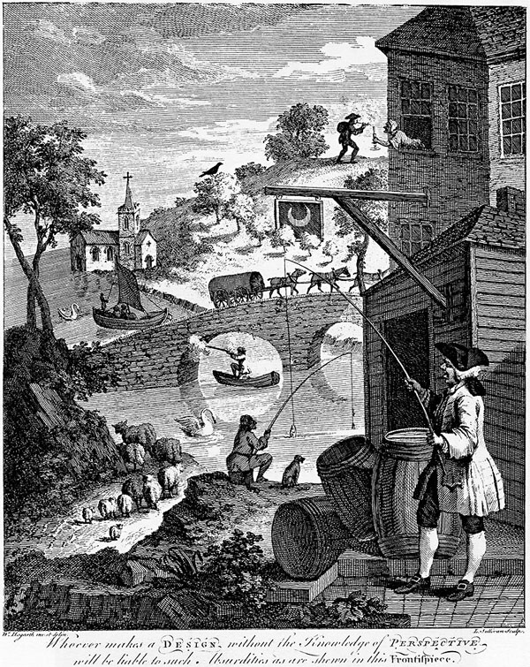
The late renaissance artists had fun mocking the muddled perspectives of the dark ages. Note the fisher in the foreground seeming to hold the pole out in front of himself, even though he's pulling in a fish from a body of water that appears to be far to his right. And what about that huge swan over on the other side of the bridge? Isn't it about as large as the horses on the bridge?
This picture shows plenty of other anomalies, but my personal favorite is the lady leaning out of a window to give a light to the smoker on the distant hillside.
In summary, again we see a mental faculty that was evidenced thousands of years ago, according to art critics, but was lost during the decline from the higher ages. Then that mental faculty returned again as we emerged from the dark ages.
Perhaps even more significant in the Lascaux paintings, many of the almost-2000 drawings in the caves show dots in the sky that seem to indicate astronomical phenomena, such as the 29-day synodic month – cycle of the Moon, or – as shown in this photo (in the video) – a pattern of dots over the bull's shoulder that replicate the pattern of the stars in the Pleiades star cluster. Is there any significance in the fact that the animal in this drawing is a bull? Some scholars argue that the painting is a bull merely because bulls were hunted by the cave painters; but the ancient bones of roasted animals that were found in the cave are all reindeer bones – no cattle were found. For this and other reasons, some university researchers argue that a bull was chosen because the Pleiades are part of the Taurus constellation, and – as you may know – the word Taurus comes from an Indo-European root that means bull.
The implication is that perhaps this constellation already was associated with the bull 15,000 or more years ago. For possible reasons that we'll later discuss in greater detail, the Pleiades also are mentioned in the Bible (Job 38:31: “Canst thou bind the sweet influences of Pleiades . . .”) and in countless other ancient texts, including old legends found here in the Americas. The fact that the Pleiades are so important to so many cultures lends credibility to the notion that the cluster of dots shown over the bull's shoulder, along with astronomical phenomena shown in other paintings, might indeed be intended to represent the Pleides and perhaps might have been associated in the painter's mind with the constellation Taurus. The reason why, perhaps, the Pleides was important to so many cultures has been forgotten – at least until quite recently. . .
(See Walter Cruttenden's book, Lost Star of Myth and Time.)
The tide turns
As suggested above, after about 500 AD, light returned, science rebounded, and abstract thinking ability improved everywhere: "The Flynn effect is the substantial increase in average scores on intelligence tests all over the world."
The Kriya Yoga connection
Unfortunately, the limited intelligence of the Dark Ages made it impossible for the average person to benefit from Kriya Yoga. For that reason, Kriya Yoga was lost for a few thousand years after having been described in detail in the ancient Bhagavad Gita.
I've posted this lengthy summary to my yugas video because it is being heavily revised, and I may not have time to complete it and post it. At my age, one never knows.
There would be no need for so much explanation if Yoganandaji had instructed me to become, say, a Roman Catholic back in 1947, for most of us have some understanding of Catholicism.
But what's Kriya Yoga? Specifically, why did it disappear for thousands of years, only to be taught again in the 19th century? Exactly what mechanism causes the rise and fall of intelligence and spiritual intuition? And why does the ability to think abstractly decline during the dark ages? Answers are presented in the Part 2 of this treatise.
Part 2.
Back to The Visit page.

Segment 2d Part 2 – The Yugas and Kriya Yoga – text for the yugas video. Backto Part 1 of the Yugas. If you haven't seen the yugas video yet, click here.
Please feel free to share this file with others; but if you modify it, please identify the modifications as your own so that they won't be confused with the author's text.
By Larry Dominus Reavis, Ph.D.

Note: Mainstream astronomers now are openly suggesting that our Sun does indeed have a dual and is part of a binary system - just as Sri Yukteswar said in 1894. See "Mainstream," below.
Sun, Moon, and precession: celestial influences
As we all know, the 360-degree spin of the Earth about its axis is called the “diurnal cycle,” or “day.”
In addition to the Earth spinning on its axis, the Moon is spinning around the Earth. Let's say we define its period as the time needed to go from one full Moon to the next full Moon. A full Moon occurs whenever the Sun, Earth and Moon, are lined up in a more-or-less straight line.
If the Earth were rotating on its axis in one spot in space instead of traveling around the Sun, we'd get a full Moon every time the Moon traveled 360 degrees around the Earth. This journey would take little more than 27 days, and is termed a sidereal month. Sidereal means that the orbit of the Moon is measured relative to the fixed stars,¹ rather than relative to the Sun or Earth. But because the Earth also is moving around the Sun in a counter-clockwise direction (from a vantage point far above the north pole) - the same counter-clockwise direction that the Moon is tracing as it moves around the Earth² - the Moon has to travel about 27 additional degrees in order to give us a new Moon. This happens because during the 27 days of the sidereal month, the Earth has traveled about 1 degree per day around the Sun (the Earth travels around the Sun in a counterclockwise motion about one degree per day - 360 degrees during every year of about 365 days), thus adding an additional 27 degrees to the 360 degrees of the sidereal month. So the total rotation of the Moon, relative to the stars, from one full Moon to the next is about 387 degrees instead of 360 degrees.
The additional 27 degrees adds more than two additional days for each monthly cycle. Therefore, the total time required is over 29 days instead of 27 days. As we all know, a period of about 29+ days is, approximately, a month. The period of 29+ days³ from one full Moon to the next is called the “lunar” or “synodic” month.
In like manner, the Earth is spinning around the Sun once every 12 months. Like the Moon, its cycle from one summer to the next or from one winter to the next is not exactly equal to a rotation of 360 degrees around the Sun. Unlike the Moon with its 387-degree cycle around the Earth from full Moon to full Moon, the Sun's cycle is shorter than 360 degrees, so that it takes about 20 minutes less time to go from, say, one winter solstice to the next than it takes the Earth to complete its full rotation of 360 degrees around the Sun. Why the 20-minute discrepancy? That will be explained below.⁴
Definitions
Reminder – in case you've forgotten: A winter solstice refers to the shortest day of the year for those of us who live north of the equator – the day when the Earth's tilt has made the rays of the Sun shine directly above those who live about 23.4 degrees south of the equator.
Some three months later, those of us in the northern hemisphere celebrate the vernal equinox while those in the southern hemisphere celebrate the autumnal equinox, the day when the northern and southern hemispheres both get the same number of hours of daylight. Or - stated another way - an equinox is when night and day are the same length.
About six months after the winter solstice comes the summer solstice (around June 21st) when the Sun is perpendicular to a location that is about 23 degrees north of the equator. The time from one equinox or solstice, such as the winter solstice, to its return, is called a “tropical year,” or “solar year.”
Note: In western cultures, the vernal equinox, around March 21, by convention (the exact date varies slightly from year to year) usually is used as the starting point for a new year. In India the autumnal equinox is used.
The slightly longer time required for a complete 360-degree rotation around the Sun, relative to the stars, is called a “sidereal year.” The term Sidereal year simply means – in a way that is analogous to the sidereal month defined above – that the Earth's year is measured relative to the fixed stars rather than relative to the angle of the Earth's axis in its relationship to the Sun. As stated above, the difference between the solar year (also known as the “tropical” year) and the longer sidereal year (relative to the fixed stars) is about 20 minutes (20 minutes and 23 seconds, to be exact). Here's why (Sri Yukteswar's explanation):
Precession of the equinoxes
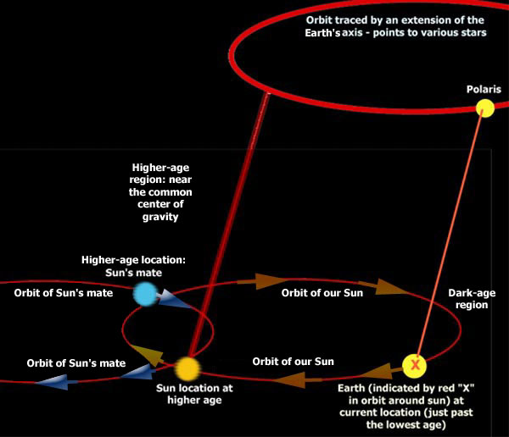
The above graphic shows how an extension of the Earth's axis currently points to our North Star, Polaris. When the Great Pyramid was build, Polaris could be seen elsewhere (due to the movement of the Sun, which carries the Earth to another location on the ellipse). For the contemporaries of the ancient Egyptians, the North Star was Thuban (a.k.a. Alpha Draconis). In the future, the North Star will be Vega. Intervening between these North Stars are long periods when no North Star is visible to the naked eye.
Like the Moon, which has to rotate more than one full circle of 360 degrees - 387 degrees, to be exact - order to go from new Moon to new Moon because of the movement of the Earth, the sidereal year is about 20 minutes longer than it would be if the Sun were standing still. That's because of a phenomenon known as the precession of the equinoxes.
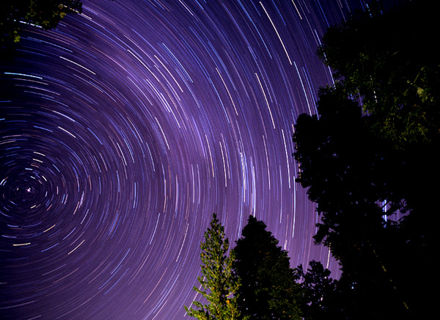
These rings indicate the path of stars as the Earth rotates as shown in this one-hour time-elapse photo. The star at the center of the rotation is our current north star - Polaris. Photo copyright by Kurt M. Lawson. Used with permission.
Perhaps the best way to understand precession is to understand that our North Pole – that is, the ice-covered northern-most point of the rotational axis of our spinning Earth – does not always point to Polaris, the star that we currently see as our “North Star.” We call it the North Star because a straight line drawn through our Earth's axis of rotation and extending into the stars would almost pass through Polaris - as can be seen in the above photo. But - as suggested above - that extension of the Earth's axis moves over a long period of time; and as it moves, it points to one or another star as the centuries pass by.
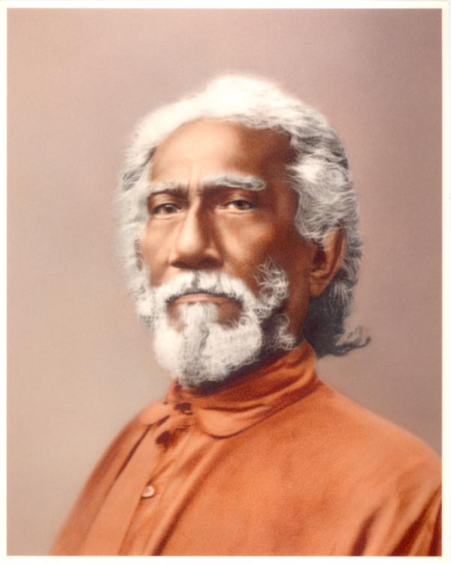
Sri Yukteswar. Photo copyright by Self-Realization Fellowship (SRF). Used under "fair use" doctrine for non-profit publication.
The reason, again according to Sri Yukteswar (and, now, many others – see http://www.binaryresearchinstitute.org/bri/research/evidence/lunarcycle.shtml), including prominent astronomers (see below), is similar to the reason why the Moon needs an additional couple of days in order to give us another full Moon. Just as the Earth is, in a sense, circling the Sun in a counter-clockwise direction away from the approaching Moon that, in a manner of speaking, is trying to “catch up” with Earth in order the produce another full Moon, the Sun is rotating clockwise toward the direction that the Earth is tracing during its journey around the Sun. The Sun is moving in this clockwise direction, says Sri Yukteswar, because it is part of a binary system. (According to NASA's Chandra researchers, 80% of all stars are in multiple-star systems - see http://chandra.harvard.edu/xray_sources/binary_stars.html.)
Like most stars, our Sun is gravitationally coupled with another celestial body. The two stars then obey Kepler's laws of motion and travel in ellipses around a common center of gravity. (The retrograde clockwise path of the Sun around the binary's center of gravity is contrary to most objects in our galaxy, for most show a counterclockwise motion; but retrograde motion is far from unique - see http://en.wikipedia.org/wiki/Retrograde_motion.)
See this 32-second video in which the Sun (shown as a yellow disk) is circling around a common center of gravity with its dual, shown in blue; or - if you have a slow web connection - download from HERE and play from your hard disk (notice that the Golden Age Satya Yuga is shown on the left of the yellow circle of the age cycles drawing).
This cycle of our Sun and its mate causes the rise and fall of the ages, cycling from higher ages down into a dark age, then returning again to a golden age. This cycle is referred to by the Greeks and Romans as the “great year,” and by Sri Yukteswar as the "electric cycle."
It's because of this precession that the ancient Egyptians, when they peered up the inclined passageway⁵in their newly built pyramid some 4000 years ago, would have seen the star Thuban (Alpha Draconis) - the star that was their north star. Since then, the location in the sky where the Earth's north pole points now is close to the star that we call Polaris, not Thuban. Polaris, therefore, currently serves as our polestar. After about 2017, Polaris will move away from this celestial north pole. And, far in the future, the star Vega will become our pole star. But during the intervening years we will have no polestar that is visible to the unaided eye.
The wobble hypothesis of Copernicus (NASA's wobble theory)
Until recently, almost all mainstream astronomers saido that the reason for precession of the equinoxes is that the Earth has a wobble – rather like a top that wobbles when it's rotation slows too much to maintain its upright position. The Earth does indeed wobble, but – says Sri Yukteswar – most of the precession is not due to wobble. Rather, it is due to the Sun being part of a binary system.
As explained above, Sri Yukteswar asserted that our Sun is one of a pair of stars that are rotating around a common gravitational center. Although this star that is the mate of our Sun has not been found, it easily could be a dark star – possible a brown dwarf, or even a small black hole.
A brown dwarf is small and many known brown dwarfs emit little radiation - making detection very difficult to accomplish (although "warm" brown dwarfs emit infrared energy, and some emit X-rays). Likewise, a black hole absorbs all light that comes close to it and only emits radiation if matter is falling into it; even then, the radiation is weak indeed (although, for black holes in a dusty environment, x-rays emitted by the dust can provide a means of detection). Because of their tiny size and weak radiation of energy, either a brown dwarf or a black hole usually is very difficult to detect.
The effects of the cycles
These cycles – the diurnal, the monthly, the yearly, and the precessional cycle of the Great Year, affect us in many ways, including effects that change our consciousness. The diurnalcycle, for example, controls the “circadian rhythm,” which is governs our sleep schedule. Trying to change it to stay awake during a night shift at work is extremely difficult, and most people never completely adjust to the change. Indeed, working the night shift increases the risk of serious disease, such as ulcers and heart disease and cancer.
The effects of the monthly cycle are more subtle, but many cultures have noticed that the period of the lunar, or “synodic,” month seems to be the same period of time as that required for the cycle of a woman of reproductive age. In fact, the word menstrual comes from the Latin word for month, mensis. Scientific evidence is weak, but a book by Louise Lacey(Lunation: A Feminine Odyssey into Fertility and Contraceptions,1975) claimed that she and 27 friends found their periods eventually began to synchronize with the Moon cycles after they avoided artificial night lighting. This monthly cycle in women also seems to be accompanied by mood changes – mainly because hormonal activity in the body is affected by the monthly period.
Annual changes have obvious effects, such as the springtime growth of flowers, new leaves on deciduous trees and other changes in plant life. The annual cycle also has documented effects on human psychology, such as the Seasonal Affective Disorder, or SAD, which results in feelings of sadness experienced by many people during the days of winter when Sunlight is minimal. The typical medical treatment for SAD requires exposure to artificial light which mimics the color temperature of the Sun – about 7000 degrees on the Kelvin scale. Old fashioned incandescent bulbs, with their color temperature of about 2700 degrees Kelvin won't work, for the energy of their long-wavelength light just doesn't affect the consciousness like the energy of short-wavelength Sunlight does.
Similarly, precession's Great Year - the long movement of the Sun in its orbit around the common center of gravity that Sri Yukteswar says is shared with a companion star – also produces changes in the mental state of people. According to him, we get more of a certain type of energy, or we utilize it more fully, as we progress closer to the binary system's gravitational center. Just as the energy of light with a color temperature of 7000 degrees K. brightens our mood, the energy that Sri Yukteswar describes enables us to progress into a higher age. I say energy because – as we have seen – Sri Yukteswar refers to the Great Year as an electric cycle; and Yoganandaji similarly says our solar system is cycling around the common center of gravity which sometimes he refers to as the magnetic center (see p735, God Speaks with Arjuna, the Bhagavad Gita). Both Sri Yukteswar's “electric cycle” and Yoganandaji's “magnetic center” imply some type of connection to energy.
Energy
So let's look at energy. Different cultures have various names for the energy that life depends upon. People in the Far East call it qi or chi, Indians call it prana, and Yoganandaji usually refers to it in English simply as “life force” or “life energy” - although sometimes he, too, uses the ancient Sanskrit term prana. It is the absence of life force, he says, that defines death of the body. Even though you pump food into the stomach of a corpse and flood the lungs of the corpse with oxygen, the corpse won't respond. When death comes, life energy goes up the spine and out through the medulla oblongata (a vital portion of the brain stem, referred to in the Bible as "the mouth of God" - see Matthew 4:4, in which Jesus asserts that man lives by every "word" - vibration of energy - that flows through the mouth of God). When life energy goes, so goes the bodily functions of assimilation, elimination, and so on. No amount of external energy from food or sunlight will compensate for that lack of internalenergy.
Where does the energy come from?
I've implied that life energy comes to us directly from a certain location in space. However, one should not imagine that we receive it only in connection with the magnetic center of our binary system. Exposure to ordinary Sunlight also is a source of energy, and – for most of us – food is the main source - at least for our present position in the cycle of the yugas. Nevertheless, the yogis assure us that, both for reasons of physical health and in order to accelerate our spiritual growth, we would do well to rely more upon bringing prana directly into our body instead of indirectly, by eating food.
Why? Because the assimilation of food always produces toxins that cumulatively damage the body. This damage is inevitable despite healthy elimination of the toxins through the bowels, perspiration, and by other means.
For that reason, I practice the recharging exercises twice daily, as taught by Yoganandaji in his Lessons. They may look like an ordinary physical exercise routine to the observer, but they are primarily mental in nature. In fact, they can be practiced from your bed if your body is unwell.
When I perform them with concentration, I am bringing prana into my body through the medulla oblongata – as mentioned is referred to as the “mouth of God” in the scriptures (see Matthew 4:4; also see this). I do this by invoking will power, following instructions found in Yoganandaji's Lessons.
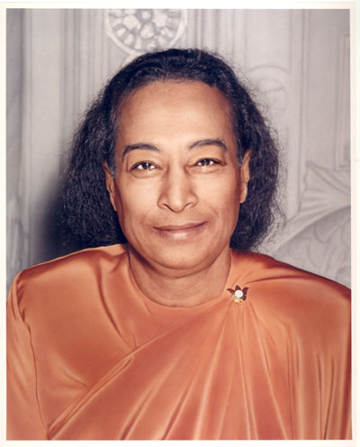
Paramahansa Yoganandaji. Photo copyright by Self-Realization Fellowship (SRF). Used here under "fair use doctrine" in a non-profit publication.
Yoganandaji gives this explanation for why direct capture of prana is superior to relying upon indirect sources, such as food:
Prana, the divine life-energy in the body, is the subjective intelligent worker in all the bodily cells. It is the “soul” of the cells. . . . ever since this intelligent life energy was projected as a vibratory force . . . it has been trying to spiritualize the bodily cells, while gross food and breath as secondary sources of life keep the cells matter-bound, in the domain of change and death. (God Talks with Arjuna: Bhagavad Gita, p365)
In other words, even though direct access to prana is difficult given our rather low position in the electric cycle, our bodies are more likely to decay and die when we rely solely upon food instead of learning how to access prana directly.
Here's how Yoganandaji presents an overview of the process (p625, Second Coming): referring to God, he says,
... It is His vibration of thought that has been condensed into light; and that light has been condensed into life force; and that life force has been condensed into electrons and protons; and they have been condensed into molecules and atoms out of which the Earth and man's body and everything in this universe is composed.
He also says:
There is no fundamental difference between matter and Spirit. Thought and matter both originate in the creative vibratory power of God. Thought, energy, and matter differ only in terms of relativity of vibration, thought being the subtlest vibration, which condenses into the light of life energy (prana) and ultimately into the gross vibrations of matter. (Second Coming, p221)
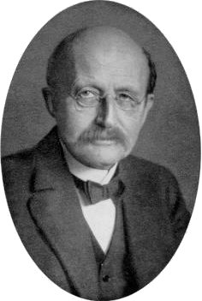
Max Planck - founder of quantum theory. Courtesy of the Clendening History of Medicine Library of the University of Kansas.
Notice how similar Yoganandaji's claim that "thought . . . condenses into . . . gross vibrations of matter" is to the claims of quantum physicists. For example, Max Planck, honored as the founder of quantum theory, said “I regard consciousness as fundamental. . . I regard matter as derivative of consciousness. . .” (The Observer, London, January 21, 1931). Many other imminent physicists, including Niels Bohr, Werner Heisenberg, Robert Oppenheimer, and too many others to mention here also argued that consciousness thought is intimately connected to matter. Certainly they did not come to this conclusion easily; most of them had to be dragged to it by the data. Indeed, Irwin Schrodinger once said he wished he never would have become involved with quantum theory (he originated the wave formulation of quantum mechanics); nevertheless, he spent most of the rest of his life studying the Vedasfrom India. By the 1950s, most of the prominant developers of quantum physics believed that there was an intimate connection between matter and consciousness.
The phrase “God's vibration of thought” is frequently identified as “aum” in Yoganandaji's writings; and the “life force” energy is frequently identified as “prana.” With this in mind, we can paraphrase Yoganandaji's above-quoted overview thus: God's vibration of aumcondenses into the light of life energy, prana, which then condenses into electrons and protons, including those in our body.
Light, consciousness, and physical energy
Aum could not properly perform its function without guidance by God the Father. According to Yoganandaji, the metaphorically male God the Father metaphorically impregnates the metaphorically female aum vibration (Mother Nature) to give birth to the one metaphorical son, Christ. It is this only begotten Christ, the "true and faithful witness" (faithful to God the Father), which permeates the aum vibration of Mother Nature; and it is this only-begotten Son - Christ - that is guiding creation. (Christ is fully manifest in all fully-realized beings, such as Jesus the Christ.)
And it is the all-permeating, guiding light of Christ within Mother Nature that gives to the physicists' observations the power to condense physical particles out of their wavelike energy, which the physicists call the "wave function." This wave function is not a wave. It is, rather, more like a concept of a wave (see the YouTube videos by quantum physicist Henry Stapp, Ph.D. here, where he talks about evidence for a cosmic consciousness, and here, where he talks about the non-physical nature of the wave function and the active role of our consciousness in these experiments; also see 2c-physics.pdf.)
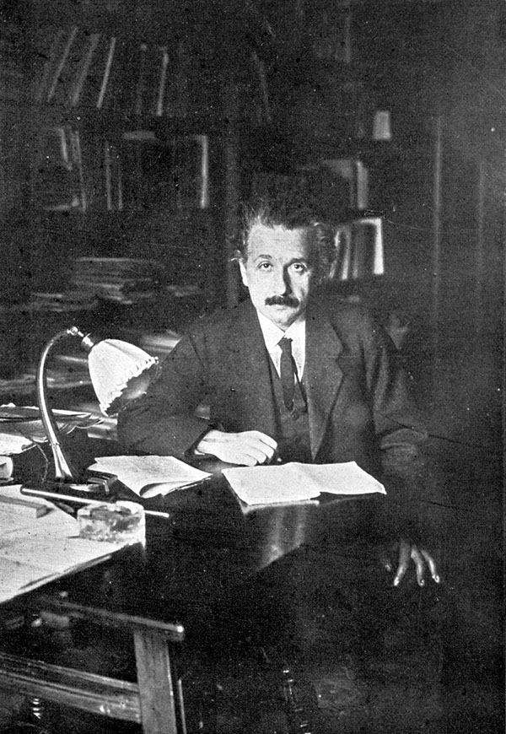
Albert Einstein, 1920. Copyright Expired.
As you probably know, physicists – since early in the 20th century – recognized the intimate relationship matter and light, or – more generally – energy. Einstein said, “What impresses our senses as matter is really a great concentration of energy into a comparatively small space.” - as quoted in Einstein & Leopold Infeld, The Evolution of Physics: The Growth of Ideas from Early Concepts to Relativity and Quanta.
Specifically related to light, he said, “All the fifty years of conscious brooding have brought me no closer to the answer to the question, What are light quanta? Of course today every rascal thinks he knows the answer, but he is deluding himself.”
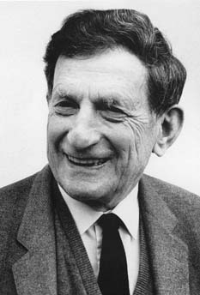
David Bohm. Public domain, provided attribution is present; which is Magnus Manske and Karol Langner, of www.theosophy-nw.org.
Perhaps Einstein was overly pessimistic regarding humanity's ability to understand quanta of light. For example, several decades later, Dr. David Bohm, (Prof. Physics, U. London) described matter as frozen light. He said, “In its generalized sense, light is the means by which the entire universe unfolds into itself. It is energy, information, content, form and structure. It is the potential of everything.”
He claims that everything is, in this sense, light, and everything is thus part of a continuum, and that objects that appear to be separate from one another actually blend into one another. This oneness of everything notwithstanding, he maintains that objects still retain their unique qualities even though, at a deeper level, they are all part of a grander reality. Does that sound like the concept of maya that we talked about in the earlier video segment? Maya, as you may recall, is like the plastic household ruler: it is divided into parts, yet remains whole. For a fuller presentation of Bohm's ideas, see his 1993 book The Undivided Universe, published in 1993 with Basil Hiley.
Returning to Sri Yukteswar's line of thinking regarding attempts to overcome the influence of time, it is this light of prana, or life force, that we must manipulate in order to become immersed, or “baptized” in the stream of Aum that flows like a river to us – in the words of the hymn Shall we Gather at the River – “from the throne of God.” And that is what kriya yoga enables us to do.
The Kriya Yoga connection
Here's Yoganandaji's explanation for the connection between Kriya Yoga and prana: Speaking again of God, he says:
His purifying, cleansing, purging power is manifested . . . throughout the universe, but is preeminent in the subtle vital air . . . that is life-giving – prana. When by Kriya Yoga . . . the accomplished yogi distills the life current out of the oxygen in the human breath and uses this pure prana to recharge his body, he unites his life with cosmic life. Breath mastery through pranayama, or life-force control, is not only the best means of drawing on cosmic energy to sustain life in the physical body, but also the highest method for attaining liberation. (see his entire statement in God Talks with Arjuna: Bhagavad Gita, p798)
In the animation (shown above), I have shown that energy, the prana that is increasingly available as we move into the higher age, as if it were colored blue. I've done that because those who have seen the energy say that it is blue. In his instructions on how to perform the recharging exercise, for example, Yoganandaji recommends that one visualize the energy as blue light that is entering the medulla oblongata.
But it isn't just the great saints who see the energy as blue light. Recently I happened to read an excerpt from the book Musicophilia, by Oliver Sacks (2007). In it he quotes a man by the name of Tony Cicoria who developed a passion for music after being struck by lightning. It happened in 1994, while talking to his mother on a pay phone. Mr. Cicoria is quoted as saying,
I saw my own body on the ground. I said to myself, 'Oh s---, I'm dead.' I saw people converging on the body. I saw a woman – she had been standing waiting to use the phone right behind me – position herself over my body, give it CPR . . . I floated up the stairs – my consciousness came with me. I saw my kids, had the realization that they would be okay. Then I was surrounded by a bluish-white light . . . an enormous feeling of well-being and peace.
“Bluish-white light,” he said – just what countless others have reported seeing during near-death experiences, and just as the yogis have describe it for countless centuries. That light cannot be seen by physical eyes, but it can be seen intuitively. Intuition is not necessarily enhanced by death, but the cessation of distracting stimuli flooding into our consciousness from the senses allows us to notice the subtle intuitive experiences.
Where does the additional energy come from during the higher ages?
I also have shown the energy of prana (in the video) as a field of radiation emitted by the magnetic center, but please don't take that literally. As Walter Cruttenden (author of Lost Star of Myth and Time) notes, the additional energy available to humanity as the solar system approaches the magnetic center may simply be due to the greater velocity with which the solar system moves through space (the velocity of all binary stars that are moving in elliptical orbits accelerates as they approach their common gravitation center).
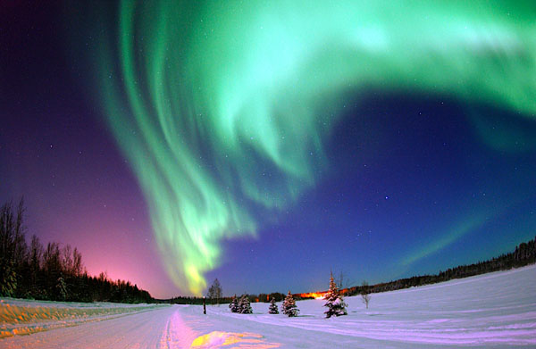
Aurora Borealis, Air Force photo taken in Alaska by Senior Airman Joshua Strang. Copyright: public domain because this is a government-created photograph.
This increase in energy might be produced in the same way that a generator produces an electric current. Just as the moving wires inside the generator cut through magnetic lines of force in order to move electrons through those wires, perhaps the magnetic field of the Earth is cutting through much larger magnetic fields from the cosmos to produce a greater charge of free electrons or, perhaps, negative ions, here on Earth. As you probably know, immense currents of charged particles constantly engulf the Earth – producing, among other phenomena, the aurora Borealis – often seen by those who live at northern latitudes (see photo taken from Alaska, above). Perhaps similar currents enhance the light of prana, the life energy. Sri Yukteswar didn't provide such details, but he and many other yogis left no doubt regarding the importance of this energy for the welfare of humanity.
It also is possible that the Sun and other stars were created more through the action of electrical forces than through the weak force of gravity (see this), and that much of their influence on earth is electrical in nature. If so, then perhaps it is the electrical interaction of the Sun and its dual that produce the psychological effects that are identified in Part 1 of this article.
Current scientific view
As implied above, conventional scientists, for the most part, do not agree with these assertions. Astronomers, especially, are likely to disagree with Sri Yukteswar's explanation for precession and instead accept the wobble hypothesis first given by Copernicus - at least until recently.
Details on the wobble theory vs. binary star theory
Copernicus was aware of precession, and speculated that it might be attributable to a wobble of the Earth – much like the wobble of a toy top that we previously mentioned. He didn't know why the Earth might wobble, but Newton provided a guess: Perhaps the Earth wobbles because the Sun and the Moon pull on the bulge at the equator. There is indeed a bulge at the equator due to the centrifugal force that results from the spinning of the Earth on its axis. Modern measurements indicate that the bulge is about 12 miles thick - thus adding about 24 miles to the earth's diameter at the equator. It is this ring of extra bulge about the equator, and only this ring – Newton speculated – that is responsible for the wobble that Copernicus had hypothesized. So, in our image, let's substitute an image of a ring for that of the Earth (image shown in yugas video - under revision).
The ring at the equator causes wobble as the gravitation of the Sun and the Moon pull on it. Because gravitational force declines with distance squared (in other words, gravitation declines a lot as distance increases a little), the part of the ring that is nearest the Sun will get a little more tug than the part of the ring that is farthest from the Sun. And because the Moon travels around the earth in almost the same plane as the Earth defines as it goes around the Sun (called the plane of the ecliptic) the Moon's gravitational effects are added to the Sun's gravitational effects: both are trying to reduce the Earth's tilt and make it stand more perpendicular to the plane of the ecliptic.
However, the Sun is so very far away from us (some 400 times as far away as the Moon), the difference in distance between the ring of the Earth's equatorial bulge that is nearest the Sun and that part that is farthest from the Sun is so small that we can ignore it for our present discussion. (All agree that the moon's influence is much greater than the Sun's.)
That leaves the Moon's influence in our simplified model. In the case of the Moon - less than a quarter-million miles from Earth - the difference between the portion of the equatorial bulge that is nearest the Moon and the portion farthest from the Moon is sufficient to create a very real "lever" that the Moon can pull on in its effort to make the Earth's axis move to an angle that is closer to perpendicular to the plane of the ecliptic.
The Moon can't change the Earth's tilt because the Earth is too massive. Nevertheless, there would be enough force at to cause a wobble, even though the tilt of the Earth would remain about 23.5 degrees relative to the plane of the ecliptic.
Now, if the Earth did wobble sufficiently (with a radius of wobble of 23.4 degrees), it could account for precession. And the evidence is that the Earth does wobble – at least a bit. However, according to Walter Cruttenden and others, the wobble only accounts for a small portion of the precession of the equinoxes.
Which explanation best fits the facts?
Given the conflict between the wobble theory and the binary theory, can observations decide which is the main cause of precession?
Both the wobble theory and the binary theory produce many of the same predictions. Both explain the circle of precession, for example. However, there are differences in the models that perhaps can help us decide which is the better model. Let's take a look . . .
First of all, astronomers have known for a long time that precession is accelerating. According to data collected in 1900, the length time necessary for the Earth to complete one cycle of precession, according to careful measurements taken by the United States Naval Observatory, was calculated to be 25,788 years. But during the 20th century, the calculated time for one complete cycle steadily declined, until it was calculated to be about 20 years less by the end of the century. If the binary theory is correct, this 20-minute-per-century decline should far exceed 20 minutes as the centuries roll by. Why? Because our Sun's motion around the common center of gravity shared with its dual should accelerate the near we get to that common center - just as all other binary star systems show acceleration of their stars as they approach their center of gravity. Thus we can see that Sri Yukteswar's model perforce must predict an accelaration of movement, while the wobble theory is at a loss to explain the observed accelaration.
Note that Sri Yukteswar, back in 1894, claimed that the precession cycle took 24,000 years rather than the then-accepted length of 26,000 years. The shorter length of the cycle now being documented by astronomers appears to attest to the superiority of his intuitive knowledge of precession.
And the error of astronomers of his day was even worse than for modern astronomers. If you would like to see how the accuracy of Sri Yukteswar's predictions held up for the next century compared to the predictions of the most advanced convention astronomers of his day, see http://www.binaryresearchinstitute.org/bri/research/calculations/100year.shtml.
Angular Momentum
If the Sun and its planets were the result of swirling gases - as astronomers believe - then each should have an angular momentum that reflects that of the swirling gases from which they were formed. That's because the principle of "conservation of angular momentum" is a well-established principle in physics. Just because the swirling gases have taken on the round forms that we now see rather than spread-out gaseous form that existed before the formation of such heavenly bodies, that change in form cannot result in any change in angular momentum.
And all of the planets do indeed show the predicted angular momentum. But not the Sun: it has but a tiny fraction (less than 1%) of its predicted angular momentum. The Sun's angular momentum, according to astronomers, is attributable mainly to it's rotation on its axis.
How did the Sun's angular momentum get lost? This was a mystery for many decades until the astronomers simply decided that the Sun's angular momentum must have simply "boiled off" as it lost matter and energy into space.
Unfortunately for the astronomers, this theory can hardly account for the "missing" angular momentum:
"About 1/10 of the solar mass should thus have be lost by now due to this effect, but if the present mass loss rate was stable throughout the Sun's "life" only about 0.01% of the Sun's original mass would have been lost. This indicates that either the Sun's mass loss must have been higher in the past or that the Sun's magnetic field has been much stronger." - http://en.wikipedia.org/wiki/Magnetic_braking
But there is no need for this (apparently incorrect) ad hoc patch to our understanding of the Sun's motion in order to account for the Sun's "lost" angular momentum. Nor is there any need to suppose that the Sun's mass and/or magnetic field were ever hundreds of times as strong as currently observed.
To the contrary: Sri Yukteswar's binary understanding of the Sun's movement presents no such "lost" angular momentum. That's because the Sun's angular momentum never was "lost" - it's still there. Where is the "lost" angular momentum? It is there in the Sun's movement around its binary orbit. If the Sun is indeed moving in an orbit around the common gravitation center of a binary system fast enough to account for precession, then this orbital motion should own most of the angular momentum. Mystery solved?
A complicating factor is the retrograde motion (see above) of the Sun. But if the Sun and its dual captured each other to form a binary system in which the two stars move in a clockwisemotion, then the angular momentum would not have diminished, but rather would now be distributed according to the laws of physics between the two stars. And indeed, the theory that some binary star systems were created after the birth of the two stars has widespread support among astronomers:
"In recent years theorists have explored four theories for binary-star birth: the capture of one star by another . . ." - http://www.astrophysicsspectator.com/topics/stars/BinaryStarBirth.html
As often happens, each of these theories has problems of its own; but these problems do not necessarily preclude retrograde motion in the binary system.
Thus the puzzle of "missing" angular momentum is neatly solved by the binary-Sun theory without having to resort to any awkward (and apparently incorrect) ad hoc patches - such as the improbable assumption that the Sun has lost most of its mass or magnetic field - a presumed loss for which absolutely no independent evidence exists.
Mainstream astronomers now are suggesting that our Sun is part of a binary system Numerous astronomers - including NASA's Davy Kilpatric, UCLA's Ned Wright, UC Berkeley's Richard Muller, U. Louisiana's John Matese and Daniel Whitmire, Caltech's Mike Brown, and others - observing irregularities in the Oort Cloud, the strange orbit of Sedna, and other inexplicable phenomena - are openly suggesting that the Sun is part of a binary system.
For example, Mike Brown, the discover of the planet Sedna, says that Sedna shouldn't be where it is. In order to account for its location, Dr. Brown suggests that the most plausible explanation for its location is that it is being affected by a large object that is in a binary system with our Sun - according to Astrobiology Magazine; see http://www.astrobio.net/exclusive/3427/getting-wise-about-nemesis
Summary of this argument
If our Sun is part of a binary system, with both the Sun and its dual traveling in elliptical orbits around their common gravitational center, then the shape of the Sun's elliptical orbit would determine the velocity of the Sun's movement as it approaches and then departs from the gravitational center of a binary system. And, says Sri Yukteswar, the closer it gets to the gravitational center, the greater the availability of prana, the energy of consciousness. The result of this increased energy is greater ability to think abstractly (see “the Flynn effect,” below) and the better one's intuition becomes. This superior mental performance accounts for the “golden ages” spoken of by the ancient Greeks, Hindus, American Indians, the Old-Testament book of Daniel, and others (see videos on Page 1).
At the lowest point, the Sun carries the Earth into a region where little prana is available. During such times, intelligence declines and the Earth enters into a dark age – known in Sanskrit as the kali yuga. The lowest point in the last kali yuga occurred around 540 AD.
Note: Other astronomical evidence that the binary theory is correct can be found in Lost Star. It also should be noted that the binary model probably is very old indeed and is not unique to India (see Wikipedia).
Summary note: Where is the physical evidence of these previous high cultures? If the earth has gone through many yugas, as suggested, and if there have been many higher ages in the past, it is reasonable to ask: "Where is the physical evidence"? Presumably, they - like us - would have had the intelligence to create skyscrapers, Coke bottles, and all the other material items that we have created. But no 32,000-year-old Coke-bottle equivalents have been found. To the contrary, there is every reason to believe that during the last peak high age of around 11,500 B.C., the quality of material life was not especially advanced. Why?
I think the answer is related in a surprising way to one of Carl Sagan's answers as to why the SETI project (Search for Extraterrestrial Intelligence) has yet to find any radio signals from other planets that seem to indicate the slightest evidence of higher intelligence. Toward the end of his life, Dr. Sagan - after noting the alarming evidence that our materialistic civilization might soon be headed for self-destruction - began to speculate that perhaps no civilization could endure such intense materialization for more than a couple of centuries before it would destroy its planet. Whether through the development of advanced weapons or because of intense damage to the environment, such intense pursuit of material power inevitable would lead to total destruction of the planet, in his opinion. If no planet, then no people; and if no people, then no radio signals; such was his line of thinking.
That makes sense in the context of the SRF monk's assertion that our current dark age period was one of the darkest ever, and more higher-age knowledge was lost this time than had been lost during many or most of the previous dark-age periods. Among the knowledge lost was an almost complete loss of knowledge of how to control one's own bodily responses to discomfort.
There are numerous stories of how Yoganandaji could sit motionless in meditation on hot sand under the hot sun of India for hours - totally oblivious to bodily discomfort. Or go swimming with the monks in the frigid Pacific no matter the water temperature. Yoganandaji himself would claim that if his body felt cold, he would simply command it to be warm; then it was warm. Most likely one of Yoganandaji's goals when asking the monks to accompany him during his frigid swims was to get them to practice mind over body - that is, to use the mind to command the body to stay warm even while immersed in cold water.
During WWII, most all of us in the U.S. learned to do something of that. Because of a shortage of coal, neither our houses nor our schools were warm. In our school, I remember a couple of winters when the temperatures in the classroom were really chilly and we never took off our warm winter coats all day long for the entire Missouri winter. Because of the shortage of teachers, all three classes in my grade were crammed into a single classroom. But I didn't complain, for it meant that I and two other kids would be crammed into a over-sized desk with a fold-down bench chair that was taken from some classroom in the school for older kids. Three little boys crammed tightly together meant I got to share some of their body heat. I could have endured without it, but the additional heat was welcome. In any case, we adapted to the cold as Fall turned into frigid winter, and I don't remember feeling especially cold after my body got use to it.
Same in Korea. When the temperatures began to drop below freezing at night, we would fire up the kerosene heater in the metal building. But when the outdoor temperatures dropped below zero, the 5-gallon containers of kerosene that fueled the heater always would empty long before dawn. Then we would wake to frigid temperatures. For a few weeks we took turns running down to the fuel dump around 2 a.m. to get more fuel for the heater. But as our bodies adjusted to the cold, we didn't bother and we spent the rest of the winter sleeping as the room air temperature dropped far below freezing.
Nearby villagers did the same. I spent many nights with near-broke Korean college students huddled inside a tiny hut - maybe six or eight of us in a small space. They invited me so that they could practice speaking English or just because I was good friends with several of them. But they probably also valued one more warm body in the room, for our body heat was the sole source of heat - a welcome source when the outdoor temperature dropped to 10F. degrees below zero. As the winter progressed, we all adapted and finally scarcely noticed the cold.
It is possible to control the body's response to such extreme environmental stimuli - even to lack of food - by using mind power. Indeed, one of Yoganandaji's goals for us was "mind over body" (and then, soul over mind). The Lessons published by SRF include teachings on how to do this. It is my guess that previous dark ages retained a good bit more of such knowledge than was the case this time. If so, it is little wonder that we turned so drastically to materialistic solutions, for we knew of no reasonable alternative.
After all, how many people know how to utilize the sun's rays when food is scarce? Consider a Catholic nun such as Therese Neumann:
("From the years of 1922 until her death in 1962, Therese Neumann apparently consumed no food other than The Holy Eucharist, and claimed to have drunk no water from 1926 until her death. - Wikipedia)
. . . and an Indian "mystic" - here and there can be found an advanced being who knows how to "ingest" prana. But the rest of us? (Predictably, Western-trained MDs asserted, without any evidence, that he and the military men who were interested in his powers, were lying - as can be seen in the above link; whereas Western fundamentalists assumed he was telling the truth and explained his powers as "of the Devil"; and life goes along its predictable path.)
Miraculous" cures without modern medical help also happen. When my late brother in law was a child and the Western-medicine doctors told his mother to take him home and give him comfort during his last hours for there was no longer any hope that he could live, she instead took him to a Mexican curandero from her hometown (Nino Fidencio, from Espinazo, N.L.). Almost immediately the boy improved and within a very few days was completely well and lived until felled by a heart attack some years ago. "Miracle"? Nonsense. The cure was merely the application of laws that most of us are but dimly aware; but those laws were known by Nino Fidencio. Perhaps, just perhaps, enough higher wisdom persisted during previous dark-age periods so that they anticipated the dead end that materialism would bring. Let us hope we, too, can see the error of our worship of materialistic "solutions" before they destroy us.
1 Quasars now are used as the fixed “stars” because their great distance minimizes parallax.
2 Counterclockwise, as seen from far away in the North Ecliptic Polar direction.
3 The exact figure is 29.531 days.
4 Please note that, in order to simplify this presentation, I am ignoring the fact that the Earth rotates 366+ times each year relative to the stars: 365+ rotations relative to the Sun (each one taking 24 hours – accounting for our day), plus one rotation around the Sun (accounting for the length of the year) equals 366+ total rotations relative to the stars.
5 The great pyramid contains a “ventilation shaft” - which is a precision-built, exceedingly straight, tunnel that points directly toward the north star.

